**Reactions of Acids and Carbonates**

**Background**

The reaction between an acid and a carbonate is a neutralisation reaction. These reactions produce water and a salt, as well as a third product, carbon dioxide.

The general reaction equation for an acid combining with a carbonate is:

acid + carbonate → water + salt + carbon dioxide

When hydrochloric acid reacts with sodium carbonate, it produces water, sodium chloride and carbon dioxide.

HCl + Na2CO3 → H2O + NaCl + CO2

You can test for carbon dioxide using limewater. The limewater goes from clear to milky if carbon dioxide is present, due to the formation of a calcium carbonate precipitate.

**Aim**: To investigate the reaction of metal carbonates with an acid.

**Equipment**: Test tubes x4

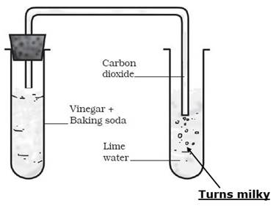

Test tube rack

Test tube stopper with rubber tubing

Limewater

Acids (hydrochloric and sulfuric)

Samples of various metal carbonates

Safety glasses

**Method**:

1. Being careful not to shake the limewater bottle, pour 2 cm of lime water into a test tube.
2. Into a second test tube, pour 2 cm of hydrochloric acid.
3. Put a pea sized sample of sodium carbonate into the hydrochloric acid, and quickly stopper it.
4. Put the end of the rubber tubing into the limewater.
5. When the reaction finishes, record your observations in the results table.
6. Repeat the experiment with other combinations of acids and carbonates, using fresh limewater each time.
7. Record all your tests and observations in the results table.

**Results**:

|  |  |  |  |
| --- | --- | --- | --- |
| **Carbonate** | **Acid** | **Observation of reaction** | **Limewater Test** |
| Sodium carbonate (Na2CO3) | Hydrochloric (HCl) |  |  |
|  |  |  |  |
|  |  |  |  |
|  |  |  |  |
|  |  |  |  |
|  |  |  |  |
|  |  |  |  |
|  |  |  |  |

**Questions:**

1. Explain how you know that carbon dioxide was produced from these reactions.
2. Why are reactions between acids and carbonates classed as neutralisation reactions?
3. Write a word equation for each of the reactions you conducted in your experiment. The first one has been started for you.
4. Sodium carbonate + Hydrochloric acid →